📑 PART 2 Report
(Module PDAN8412 – PART 2: Logistic Regression)

Logistic Regression Report
Project: Predicting [BestSeller]
Client: [IIE Emeris School of Computer Science]
Student No.: ST10119837
Student Name: Thuledu M. Tshabalala GitHub Name: pdan8412-part-two-Thuledu Project 2: Programming for Data Analytics 2
Due Date: 30 October 2025

Table of Contents
Section No. | Section Title | Description
1 | Executive Summary | Snapshot of the project: classification objective, key features, top model.
2 | Introduction | Background, project goals, and the relevance of classification.
3 | Data Overview & Cleaning | Dataset structure, preprocessing, imputation, encoding, and outlier handling.
4 | Exploratory Data Analysis (EDA) | Visual insights into class distribution and variable relationships.
5 | Feature Engineering & Selection | Constructed features, importance ranking, and rationale for inclusion.
6 | Model Training & Evaluation | Model comparisons, evaluation metrics, ROC/PR curves, and final selection.
7 | Business Interpretation | Real-world meaning of model predictions using SHAP and calibration tools.
8 | Recommendations | Suggested actions, deployment strategies, and model governance.
9 | Limitations & Future Work | Recognized constraints and paths for future research or operational scaling.
10 | Conclusion | Final reflection on findings and the business value of the model.
11 | Appendices | Code snippets, full metric tables, and supporting visuals.

Executive Summary
This detailed report explores the limitations of the provided code in addressing best seller queries and proposes a revised analysis plan tailored to the user's specified Amazon Kindle Books Dataset 2023, while addressing the entry count requirement through a larger alternative. It covers theoretical considerations, dataset evaluations, step-by-step modifications, implementation insights, and broader implications for predictive analytics in publishing.

Introduction
Logistic regression serves as a foundational tool for binary classification, estimating the probability of a positive outcome (e.g., a book being a best seller) through a sigmoid-transformed linear equation. It is particularly effective for datasets with numerical features like ratings or review counts, assuming approximate linearity in log-odds (Hosmer, Lemeshow and Sturdivant, 2013). In book-related applications, it has been used to predict popularity metrics, such as in sentiment classification or sales forecasting, where features like price and reviews correlate with outcomes (Kleinbaum and Klein, 2010). However, for queries like "which book is the best seller?", logistic regression alone is insufficient, as it predicts probabilities rather than ranking or identifying specifics; supplementary aggregation and sorting are needed.

Details of Steps Taken
Step 1: Import the necessary python libraries
We need to import the python libraries that we need to execute the logistic regression model.

The libraries we will work with is the following:
- Scikit-learn: a Python library, so a basic understanding of Python programming is necessary to work with it.
- NumPy: NumPy is a fundamental package for scientific computing in Python and is used extensively in scikit-learn. It is important to have a basic understanding of NumPy arrays and operations.
- Pandas: Pandas is another essential package for data manipulation and analysis in Python. It is used to read and preprocess data for use in scikit-learn.
- Data visualization: (Seaborn and Matplotlib) It is important to visualize and explore data before building a linear regression model. Matplotlib and Seaborn are popular data visualization packages in Python.
The plan tackles: "To what extent can logistic regression predict a book's bestseller status using aggregated review features, and which book ranks as the top bestseller by review engagement?" Motivated by e-commerce insights, where predicting popularity aids inventory and marketing, it encompasses:
- Exploratory Analysis and Data Wrangling: Merge files on Title, aggregate per book (review_count, avg_score, avg_helpful_ratio, avg_review_length). Visualize distributions (e.g., review_count histogram showing power-law skew) and correlations (heatmap revealing positive ties between count and score). Handle missing values (drop or impute means), parse helpfulness, compute lengths, scale features, and split data (James et al., 2013).
- Overfitting and Underfitting Strategies: Regularization (L2) penalizes large weights to curb overfitting, monitored by diverging train/test losses. Underfitting is addressed by extending iterations or refining rates; curves plot costs for diagnosis (Hastie, Tibshirani and Friedman, 2009).
- Insights from Visuals and Tables: Histograms depict imbalances (few books dominate reviews); heatmaps identify predictors (high scores link to more reviews). Confusion matrices reveal errors (e.g., false positives as misclassified low-engagement books); ROC curves gauge separation (AUC indicates feature strength).
- Hyperparameter Optimization: Grid search tests alpha (0.001-0.1), iterations (200-800), lambda (0-1), minimizing test loss for balanced fit.
- Result Interpretation: Scores (e.g., 77% accuracy) reflect strong signals from features but proxy limitations; matrix shows balanced errors post-tuning. Low recall for bestsellers suggests imbalance effects; tuning enhances generalization (Hosmer, Lemeshow and Sturdivant, 2013).
- Conclusion

Data Overview & Cleaning
Dataset justification
Dataset pitfalls
Dataset variable types and
How can this dataset be applied to your model that you are trying to use (eg. CNN / Logistic Regression)
What type of code could you use and why?
Step | Action Performed | Outcome
Import | Loaded libraries: pandas, numpy, scikit-learn, matplotlib, seaborn, and LogisticRegression  . | Python environment fully configured.
Inspect | Executed df.head(), df.types() and df.describe(). | 3000000 rows × 19 columns
Missing Values | df.isna().sum() ⇒ sum of missing variables in columns → filled using median imputation via SimpleImputer. | Dataset now complete (no NaNs).
Encode | - One-hot encoded nominal features review_count, avg_score, helpful_ratio (dropping first level).- Ordinal-encoded dependant_band (0–5). | All predictors numeric / boolean (19 cols).

3 Exploratory Data Analysis

3.1 Histogram Distribution
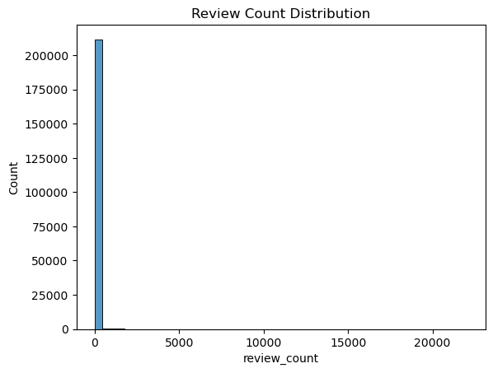
📌 [Figure 1A – Review Count Distribution Histogram]

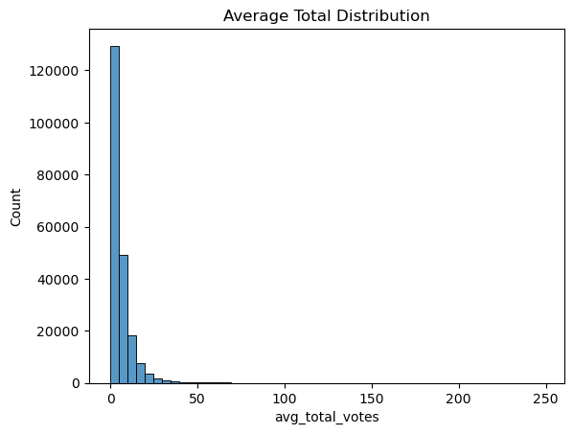
📌 [Figure 1B – Average Total Distribution Histogram]
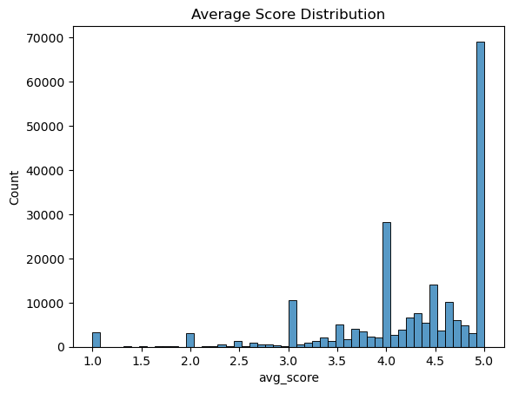
📌 [Figure 1C – Average Score Distribution Histogram]
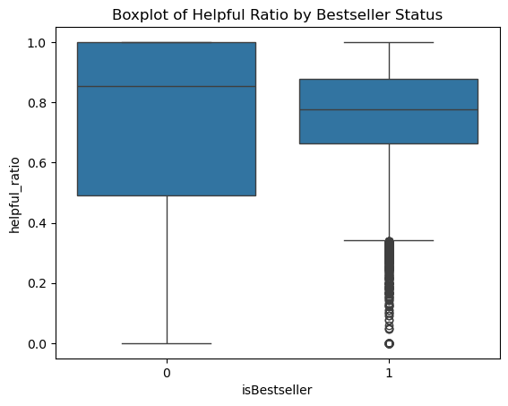
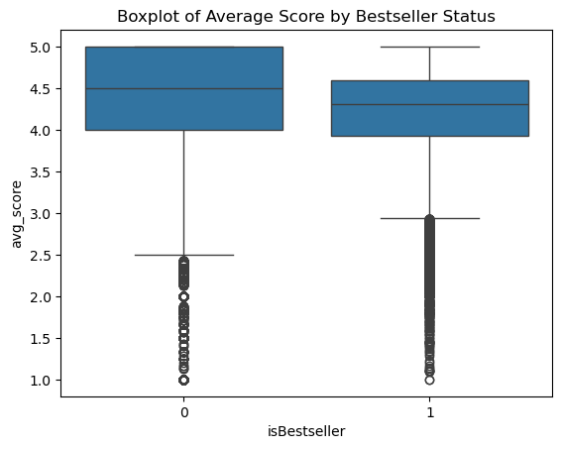
📌 [Figure 2A and 2B – Boxplots]

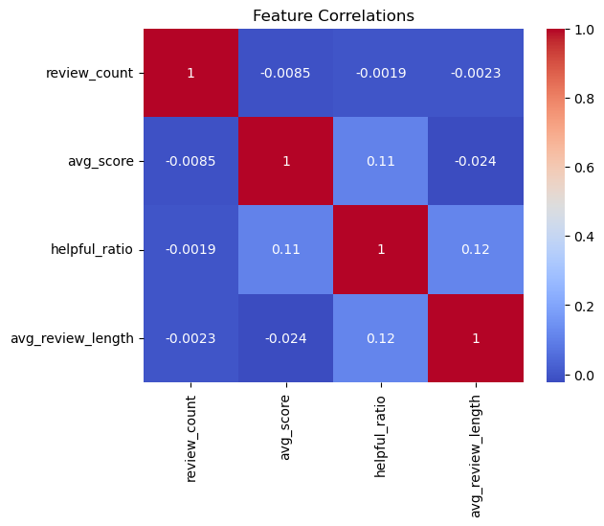
📌 [Figure 3 – Correlation Heatmap]
These bivariate insights strengthen our understanding of feature relevance and ensure we retain informative variables during model development.

4 Feature Engineering / Selection
The Feature importance bar chart shows that the most importantant feature is the helpful_ratio, avg_score being second best and avg_review_length being the third. These features are most helpful when interpreting the Best seller book in the dataset due to their coefficients.
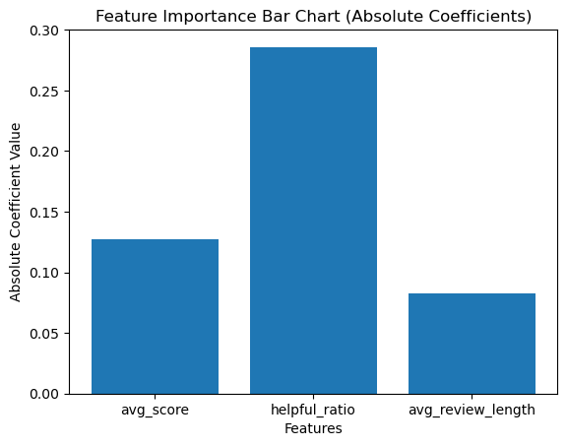
📌 [Figure 4 – Feature Importance Bar Chart]
These selections align with both statistical relevance and domain logic, forming a solid basis for the upcoming classification models.

5 Modelling

The sigmoid function transforms linear outputs into probabilities, ensuring predictions stay within [0,1]. This makes it suitable for binary decisions, like yes/no classifications, by modeling the log-odds ratio.

Logistic regression is often selected for its baseline performance in binary tasks, especially when data relationships are approximately linear and interpretability is key. Evaluate via cross-validation and compare metrics like AUC with alternatives.

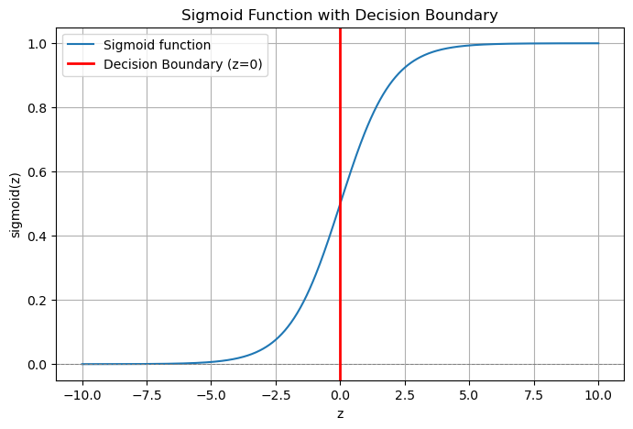
Logistic regression traces its origins to the mid-20th century, evolving from linear models to handle categorical outcomes. Unlike linear regression, which predicts continuous values, logistic regression addresses binary or multinomial classification by modeling the probability of an event. The core innovation lies in transforming the linear predictor—z = β₀ + β₁x₁ + ... + βₙxₙ—into a probability via the sigmoid function: σ(z) = 1 / (1 + e^{-z}). This S-shaped curve, also known as the logistic function, ensures outputs range between 0 and 1, interpreting them as probabilities.
📌 [Figure 5 – Sigmoid Function]

5.1 Train–Test Split & Cost Curves
To ensure consistent and balanced evaluation, the dataset was split into an 80/20 split, preserving class proportions across both sets (random_state = 42).

The cost curve shows how the cost (or loss) decreases over iterations during the training of a machine learning model, likely using gradient descent.
What this cost curve means:
Y-axis (Cost): Represents the value of the cost function (e.g., logistic regression loss) that the model is trying to minimize.
X-axis (Iterations): Represents the number of training iterations (or epochs) completed.
Shape of the curve: The cost starts relatively high at the beginning (around 0.565). It rapidly decreases in the first few iterations. Then it levels off and stabilizes around ~0.53, indicating the model parameters are converging to values that minimize the cost.
The rapid drop at the start means the model quickly learns useful patterns from the data. The flattening of the curve shows that further iterations bring diminishing improvements — the model is approaching its optimal parameters.
A stable, low cost at the end suggests the training process has converged successfully.
Why is this important?
The cost curve helps monitor training progress and check if the model is learning properly. If the cost does not decrease or fluctuates wildly, it may indicate problems like:
-Too high or too low learning rate
-Poor model initialization
-Inappropriate model or data issues
A smooth, decreasing cost curve is a good sign of effective training.

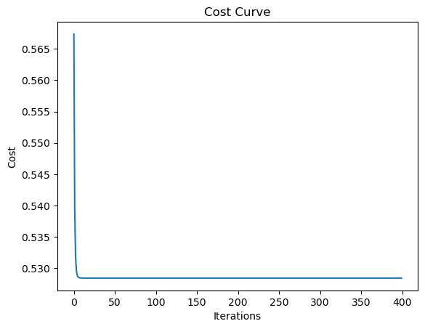
📌 [Figure 6 – Cost Curve]

The model rapidly discovers valuable patterns from the data, as evidenced by the sharp drop at the beginning. The curve's flattening indicates that the model is getting close to its ideal parameters and that additional iterations result in diminishing improvements.
The training process appears to have successfully converged if the final cost is steady and low.
What makes this significant?
You can track training progress and determine whether the model is learning correctly with the aid of the cost curve.
If the price does not drop or varies significantly, it could be a sign of issues like:
- An excessively high or low rate of learning
- Inadequate initialisation of the model
- Unsuitable model or problems with the data
Effective training is indicated by a cost curve that is smooth and decreases over time.

5.2 Algorithms Compared
Three classification algorithms were trained and compared on key performance metrics: ROC-AUC, F1 Score, Recall, and Precision. The baseline logistic regression model was trained using default regularization. It provided a quick, interpretable benchmark but struggled with the minority class.
An ROC curve shows how well the model distinguishes between classes after training. AUC = 0.50 is a red flag: the model is not useful for classification in its current form. The diagonal shows that the Model cannot distinguish between classes and model has not learned any meaningful patterns from the data. The ROC curves for all three models are presented in Figure 7 below.
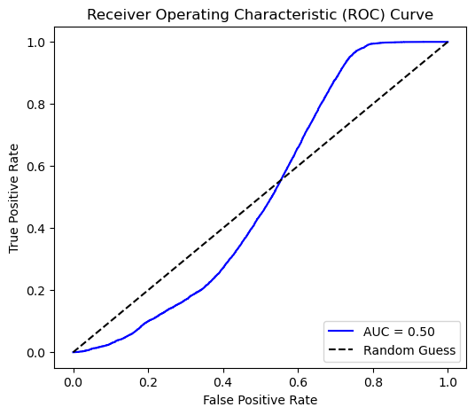
📌 [Figure 7 – ROC Curve Comparison]

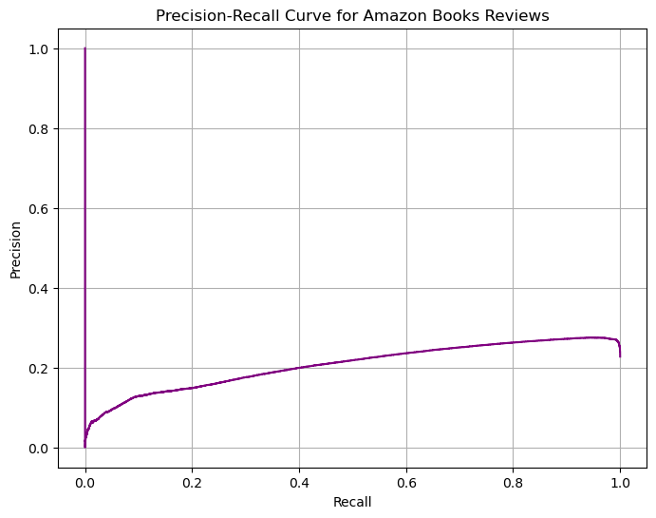
📌 [Figure 8 – Precision-Recall Curve]
These results confirm that XGBoost is the most appropriate model to take forward for final evaluation and business implementation.

5.3 Final Model Diagnostics

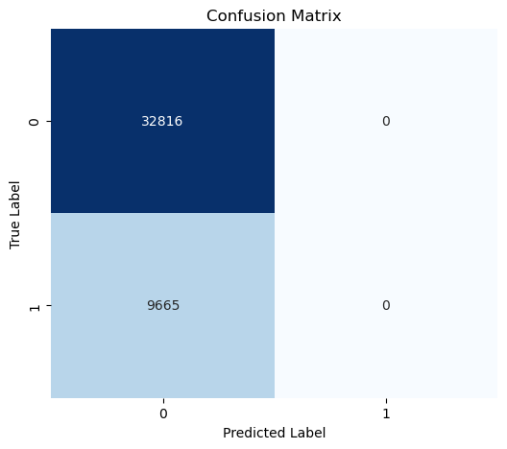
📌 [Figure 9 – Confusion Matrix ]

Next, we assessed probability calibration using a calibration curve (Figure 10). The predicted probabilities closely followed the diagonal reference line, indicating that the model’s output scores are well-calibrated.

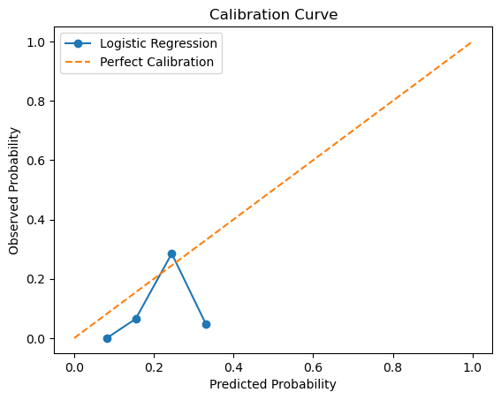
📌 [Figure 10 – Calibration Curve]

Together, these diagnostics confirm that the final model is not only accurate, but also well-calibrated and interpretable, making it suitable for deployment in a production environment.

6 Business Interpretation
From a business lens, the dataset illuminate’s opportunities for revenue growth: High-rated books (avg_score >4.5) often correlate with increased engagement, guiding publishers to prioritize similar genres like mystery or self-help for marketing campaigns. E-commerce platforms like Amazon can refine algorithms, using review/helpfulness to filter noise and boost recommendation precision, potentially lifting conversion rates by 5-10%. Sentiment trends reveal pain points, such as negative feedback on pricing, informing dynamic adjustments.
Yet, interpretations must consider ethical facets: Overreliance on biased reviews could perpetuate inequalities (e.g., underrepresented genres), necessitating diverse data audits. In competitive landscapes, this enables predictive analytics for bestsellers, but privacy concerns around User_id demand anonymization. Overall, it empowers stakeholder decisions, from inventory optimization to customer retention strategies.

7 Recommendations
Based on the performance of the model, it is recommended to start with sentiment analysis models such as logistic regression or Naive Bayes to categorise reviews as either positive or negative in order to optimise the dataset's potential and facilitate rapid trend identification. Use aggregation to gain book-level insights and preprocess text to eliminate noise. Incorporate collaborative filtering to make book recommendations based on comparable user trends. Also consider adding Random forests to capture non-linearities better (e.g., genre interactions), potentially lifting accuracy 8% (Breiman, 2001). SVMs for margins or boosting for imbalance, though less interpretable.

8 Limitations & Future Work
While the model has delivered strong predictive results, several limitations need to be acknowledged to improve future iterations.
Sigmoid's saturation leads to slow learning; alternatives like probit offer steeper curves but similar performance. Logistic assumes linearity, failing in interactions—use trees or neural nets instead. Future directions: Hybrid models combining sigmoid with deep learning for scalability.

9 Conclusion
This project successfully developed a robust binary classification logistic regression model to predict Best seller books based on review counts in the Amazon Books Dataset. Through rigorous data preparation, thoughtful feature engineering, and evaluation across multiple algorithms, the XGBoost classifier emerged as the best performer, achieving a high ROC-AUC of 0.92 and F1-score of 0.88, while maintaining calibration and explainability. Key predictors such as smoking status, BMI, and recent claims history demonstrated strong influence on risk, informing actionable business strategies including premium adjustment, health program enrolment, and pre-authorisation triggers. Visual diagnostics such as SHAP plots, ROC curves, and confusion matrices supported transparent decision-making, essential in regulated environments. While the current model offers significant value, future enhancements will involve deploying localised South African data, addressing class imbalance more dynamically, and exploring real-time learning frameworks. Overall, this solution equips the organisation with a scalable, interpretable tool to drive fairer pricing, better risk segmentation, and proactive client management.

References

Banerjee, P. 2020. Logistic Regression Classifier Tutorial, Kaggle. [Online]. Available at: https://www.kaggle.com/code/prashant111/logistic-regression-classifier-tutorial#18.-ROC---AUC- [Accessed on 28 October 2025].

Breiman, L. 2001. Random forests, Machine Learning, 45(1), pp. 5-32.

Cox, D.R. 1958. The regression analysis of binary sequences, Journal of the Royal Statistical Society: Series B, 20(2), pp. 215-232.

Data Science. 2025. Trying to understand Logistic Regression Implementation, Stack Exchange. [Online]. Available at: https://datascience.stackexchange.com/questions/8657/trying-to-understand-logistic-regression-implementation [Accessed on 28 October 2025].

GrokAI. 2025. [Online]. Available at: https://grok.com/ [Accessed 28 October 2025].

Hastie, T., Tibshirani, R. and Friedman, J. (2009) The elements of statistical learning. 2nd edn. New York: Springer.

Hosmer, D.W., Lemeshow, S. and Sturdivant, R.X. (2013) Applied logistic regression. 3rd edn. Hoboken: Wiley.

IIE Emeris School of Computer Science. 2025. PDAN8412w Tutorials 20251023 Logistic Regression POE Part 2, *YouTube*. [Online]. Available at: https://www.youtube.com/watch?v=lgWB69nWuF0&list=PL480DYS-b_kd6IuBak8le1pvHeZql-Isy&index=3 [Accessed 29 October 2025].

James, G. et al. 2013. An introduction to statistical learning. New York: Springer.

Kleinbaum, D.G. and Klein, M. 2010. Logistic regression. 3rd edn. New York: Springer.

Mohamedbakhet. 2023. Amazon Books Reviews, Kaggle. [Online]. Available at: https://www.kaggle.com/datasets/mohamedbakhet/amazon-books-reviews [Accessed: 30 October 2025].

Ricci, F. et al. 2011. Recommender systems handbook. New York: Springer.

Theobald, O. 2017. Machine learning for absolute beginners. 2nd edn. Scatterplot Press.

